AI-POWERED PERSONALISED MENU SYSTEM: BRIEF
Team: Ginseng

PROBLEM
Amid the catering industry’s accelerated digital transformation, campus and corporate canteens (centralized dining scenarios) face a conflict between diverse demands and standardized services. Traditional static menus have three core flaws: they fail to update real-time dish availability, calories, and allergens (struggling to meet special dietary needs); information asymmetry in manual ordering causes dish-user mismatches and severe food waste; and lengthy meal selection leads to low efficiency.
Existing solutions (e.g., smart screens, online ordering apps) only offer basic functions like information display and order submission, lacking personalized recommendations and multimodal interaction. High-end commercial systems are overly costly, while low-cost options have rudimentary features—neither fits canteens’ budgets or operational needs. The market urgently needs a low-cost, highly adaptable, and flexible intelligent solution to fill the gap in canteen digital upgrading.
OUR SOLUTION
The AI-Powered Personalised Menu is an intelligent canteen assistant system based on IoT and AI technologies. With the Raspberry Pi 4B as its core control unit, the system incorporates hardware such as cameras, RFID readers, and microphones, and is equipped with multimodal models including GLM-4.5V/DeepSeek-V3.2 to build a full-link architecture covering hardware integration, edge computing, and cloud-based management. It realizes core functions such as dish recognition, personalized recommendations, and multimodal intelligent interaction (voice, touch, card swiping), requiring no complex deployment and being suitable for campus and corporate canteen scenarios.
For data management, MongoDB stores dish info, user preferences, and interaction logs, while ThingsBoard enables real-time device monitoring and data visualization. The self-developed Web terminal supports dish/user management and data analysis.
With no need to modify existing canteen facilities and a total equipment cost of just 1118 CNY, the system supports bulk deployment—lowering user operation barriers, providing data support for canteen operations, and achieving precision services, cost reduction, and efficiency improvement.
HARDWARE USED
- Raspberry Pi 4B (Edge Computing and Control Core)
- TJC8048X543_011C_I LCD Touch-screen (Human-Machine Interface)
- USB to TTL Adapter Board (Power and Communication Adaptation)
- PCR532 RFID Module (User Identity Verification)
- USB Desktop Microphone (Voice Input Capture)
- OpenMV4 H7 Plus Smart Camera (Food Item Image Capture and Preprocessing)
- Four-Sided Single Speaker (Voice Feedback Output)
- HC-SR04 Ultrasonic Distance Sensor Module (Human Presence Detection Wake-up)
DEMO VIDEO
1. 🎦 Full demo video 2. 🎦 2min short demo video
PHOTOS
- Final assembled prototype
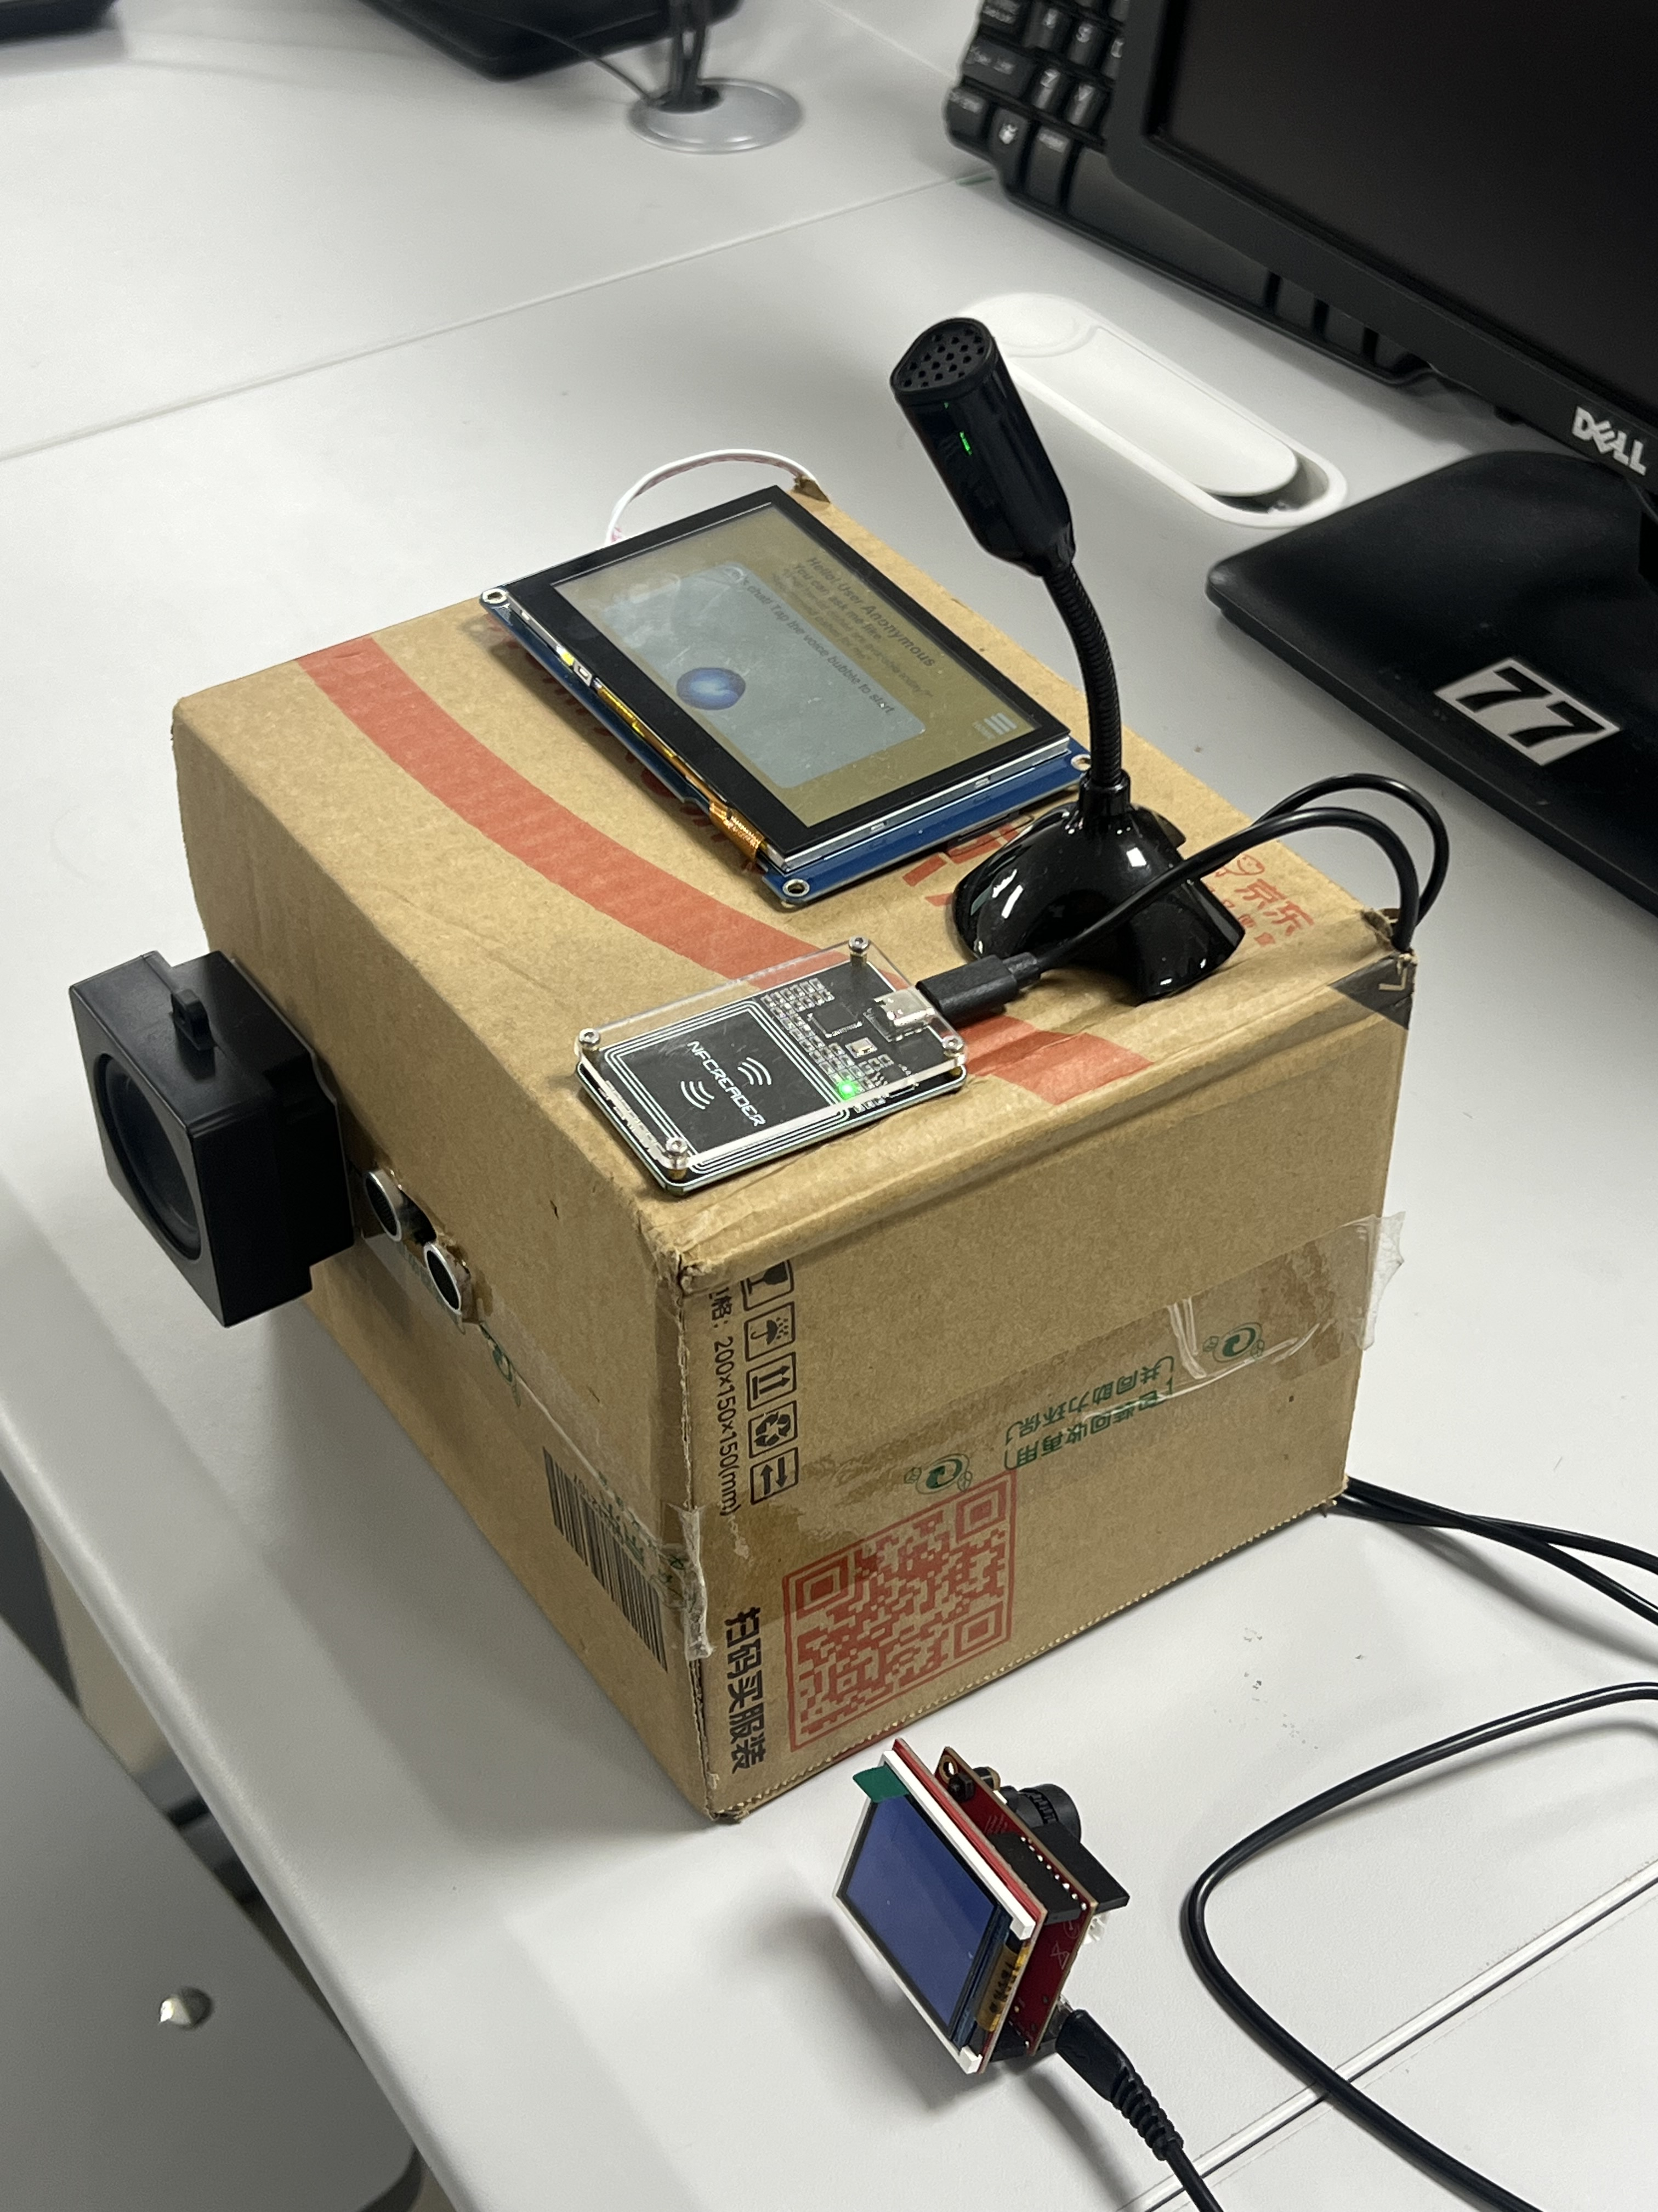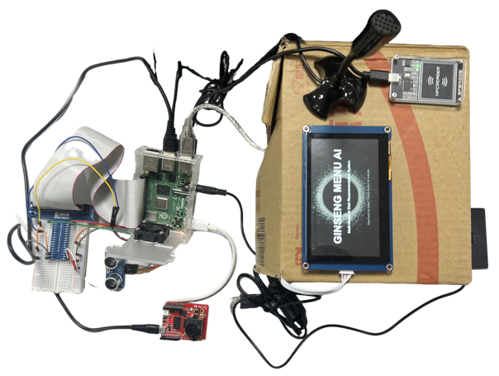
- IoT platform: Thingsboard displaying dashboard
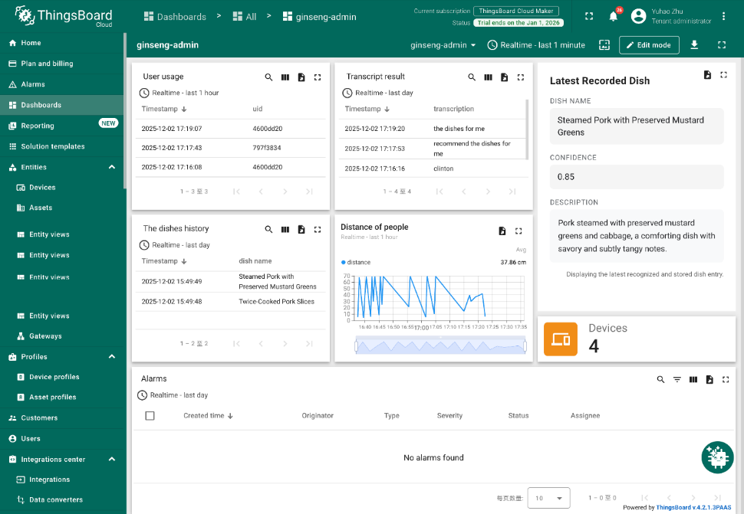
- Web application displaying Admin panel
